# YOUTH RED CROSS OF CEG



## AGARAM REPORT

08 OCTOBER 2023

**OBJECTIVE OF YRC:**

The main objective of YRC is to inculcate in the Youth of our country :

* An awareness on the care of their own health and that of others.
* An understanding and acceptance of civic responsibilities and acting accordingly with humanitarian concern ,to fulfil the same.
* To enable the growth and development of spirit of service and sense of duty with dedication and devotion.
* To foster better friendly relationship with all without any discrimination.

**ABOUT YRC:**

* The Red Cross Society is a world wide, well known, universally accepted, admired and internationally identified humanitarian service organisation.
* YRC is the most important constituent of its mother organization, Indian Red Cross.
* YRC in Anna University was established in the academic year 2002-03 as per the orders of the Govt. of Tamil Nadu.

**MOTTO OF YRC:**

*Health-* Protection of Health & Life

*Service-*Service to the Sick and Suffering

*Friendship*- Promotion of National & International Friendship,to develop the mental and moral capacities of the youth

### PROGRAMME OFFICERS

### Programme Co-ordinator (UniversityLevel)

### Prof. Dr. S.Thanigaiarasu

### Programme Officers (College Level)

### Dr.D.Narashiman – Unit - 1

### Dr.V.Gomathi – Unit - 2

### Dr.R.Lavanya – Unit - 3

### Dr.K.Malar Mohan – Unit - 4

**OFFICE BEARERS 2023-2024**

|  |  |  |
| --- | --- | --- |
| **S.no** | **NAME** | **DOMAIN** |
| 1. | ABINITHI R | EVENTS |
| 2. | KAILAASH R.M |
| 3. | MURASOLIMARAN |
| 4. | POOJA T |
| 5. | SUDHAKAR K |
| 6. | DHAVASRI M | ATTENDANCE AND DOCUMENTATION |
| 7. | HUSSWATH |
| 8. | NITHYASHREE K |
| 9. | ANULATHA S K | CONTENT AND DESIGN |
| 10. | BABY M |
| 11. | HARIDHARANI T |
| 12. | THENAMBIKA P |
| 13. | ABINITHI R | WEBSITE |
| 14. | MURALI B |
| 15. | DEEPAKRAJ C N | BLOOD REQUEST |
| 16. | SANDHYA SS |
| 17. | ABINITHI R | ALUMNI RELATION |
| 18. | KAILAASH R.M |
| 19. | NIVETHA R |
| 20. | SUDHAKAR K |

### DETAILS OF EVENT :

NAME : Personality Development

DATE: 08.10.2023

TIME: 8.30 AM-12.30 PM

VENUE: TAG Auditorium

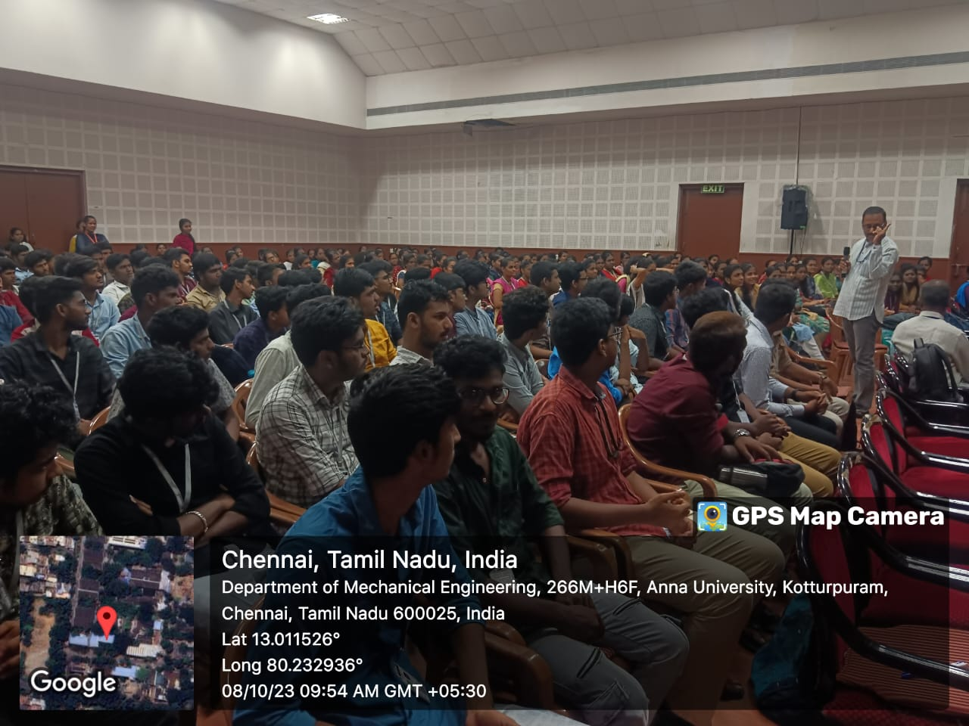

The motivational talk started at 9.00 am in the TAG Auditorium. More than 200 students participated. **DR.K,Vipinendran , Printing and Industrial Engineering, Management Studies** ,motivated the young minds of YRC CEG students with his experience and by conducting activities. The talk ended at 12.30 pm ,then the chief guest was presented with a memento.

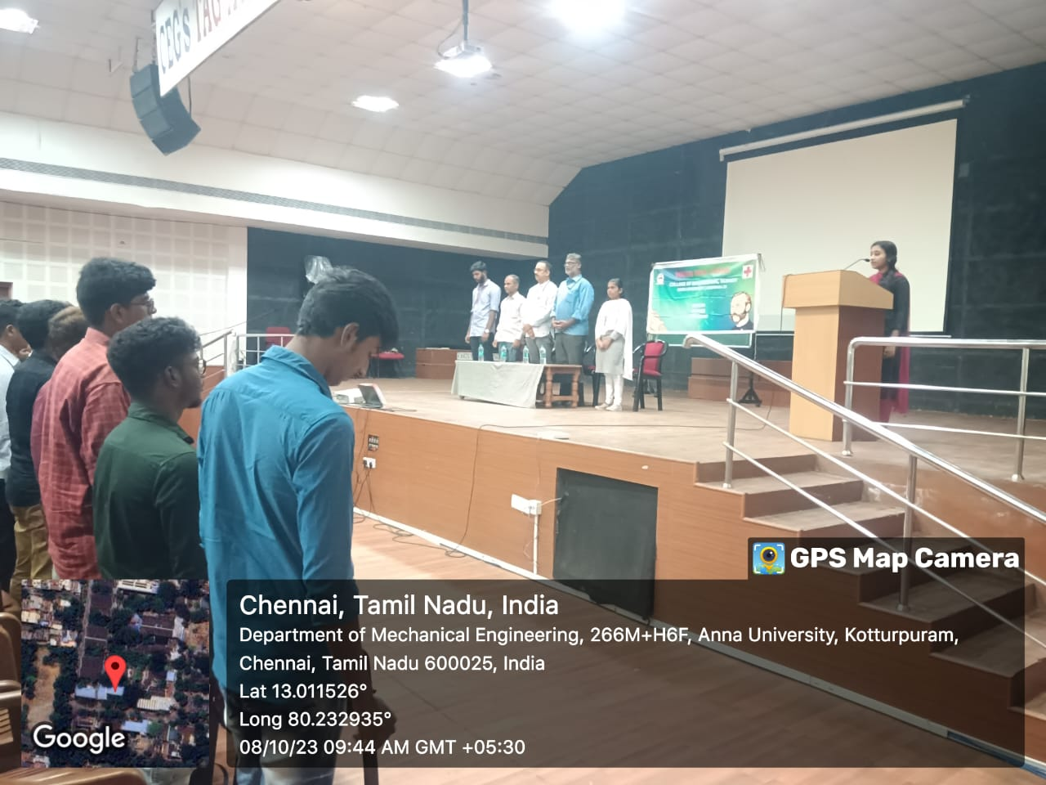

### ACTIVITIES CONDUCTED:

### FOCUS AND MEMORY BUILDING

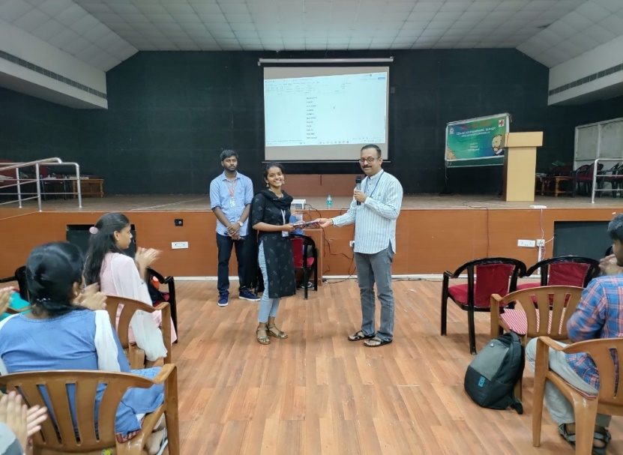

**Objective**: Enhance Focus and Memory Skill

* Participants Close Eyes
* Narration by Event Host (Sir)
* Words Presented as a Story
* Participants Recall words in Sequential Order
* Time Limit for Response

**NEWSPAPER TOWER BUILDING**

**Objective:** Build Tallest Tower

* Focus on Teamwork
* Cost-Efficient Design
* Time Limit for Construction
* Judging Criteria: Height and Stability
* Creativity Encouraged, Engages Engineering and Collaboration Skills

**FOCUS AND CONTROL**

Objective: Building Confidence and Self-Control

* Overcoming Fear Element
* Participants Required to Blow Fired cotton into Mouth
* Symbolic of Overcoming Fear
* Demonstrates Mental Resilience
* Encourages Facing Fears Head-On